Formatting your artist statement
Your artist statement is a BRIEF description of what you are addressing with your work, why it is important, and how it is addressed technically. Your artist statement should be one or two paragraphs long.

Your artist statement is a compliment to what you present visually. It should not take the place of what you present visually. It does not need to detail every aspect of your work; your work should speak for itself.

The first sentence of your artist statement should be your “thesis.” You should present the main idea(s) behind your work as an issue that is universal, not an idea that only you are “interested” in. Write in an active voice using the present tense. Avoid using “I”. Avoid phrases like “I think”, “I hope”, “I feel”, “I am interested”, etc.
Examples:
1.“Climate change will affect the habitable world in our lifetime and surely affect the futures of our children.”

2.“Our memories of childhood shape who we are as adults.”

The middle portion of your artist statement should expand on your idea and relate it to your work.
Examples:
1.“As we alter our environment to plan for the effects of climate change, the line between what is natural and what is industrial becomes blurred. The landscapes of our contemporary world are otherworldly and fascinating.”

2. “As we build independent lives as adults, our homes become a reflection of the collection of our distant and recent memories. The objects we collect and the way we arrange them are portraits of our inner selves.”

The final portion of your artist statement should present your process and/or the translation of your ideas into your work.
Examples:
- “The metal and concrete of the industrial world and the barrenness of the winter landscape are combined and reflected in the muted earth tones in my work.”

2. “Through interviews with my relatives and photographic documentation of their homes, I create intimate portraits of those I love. The palettes I choose, the light cast, and the scale of the objects in space are all a reflection of the mood of my subjects’ memories.”
***Avoid overly complicated or flowery language, generalizations, other people’s ideas or quotes, and overly technical jargon. Remember, your artist statement should help people to understand your work better, not leave them feeling confused, uneducated, or excluded from the art world. Take your time to say what you mean in the clearest terms possible-- quality over quantity!

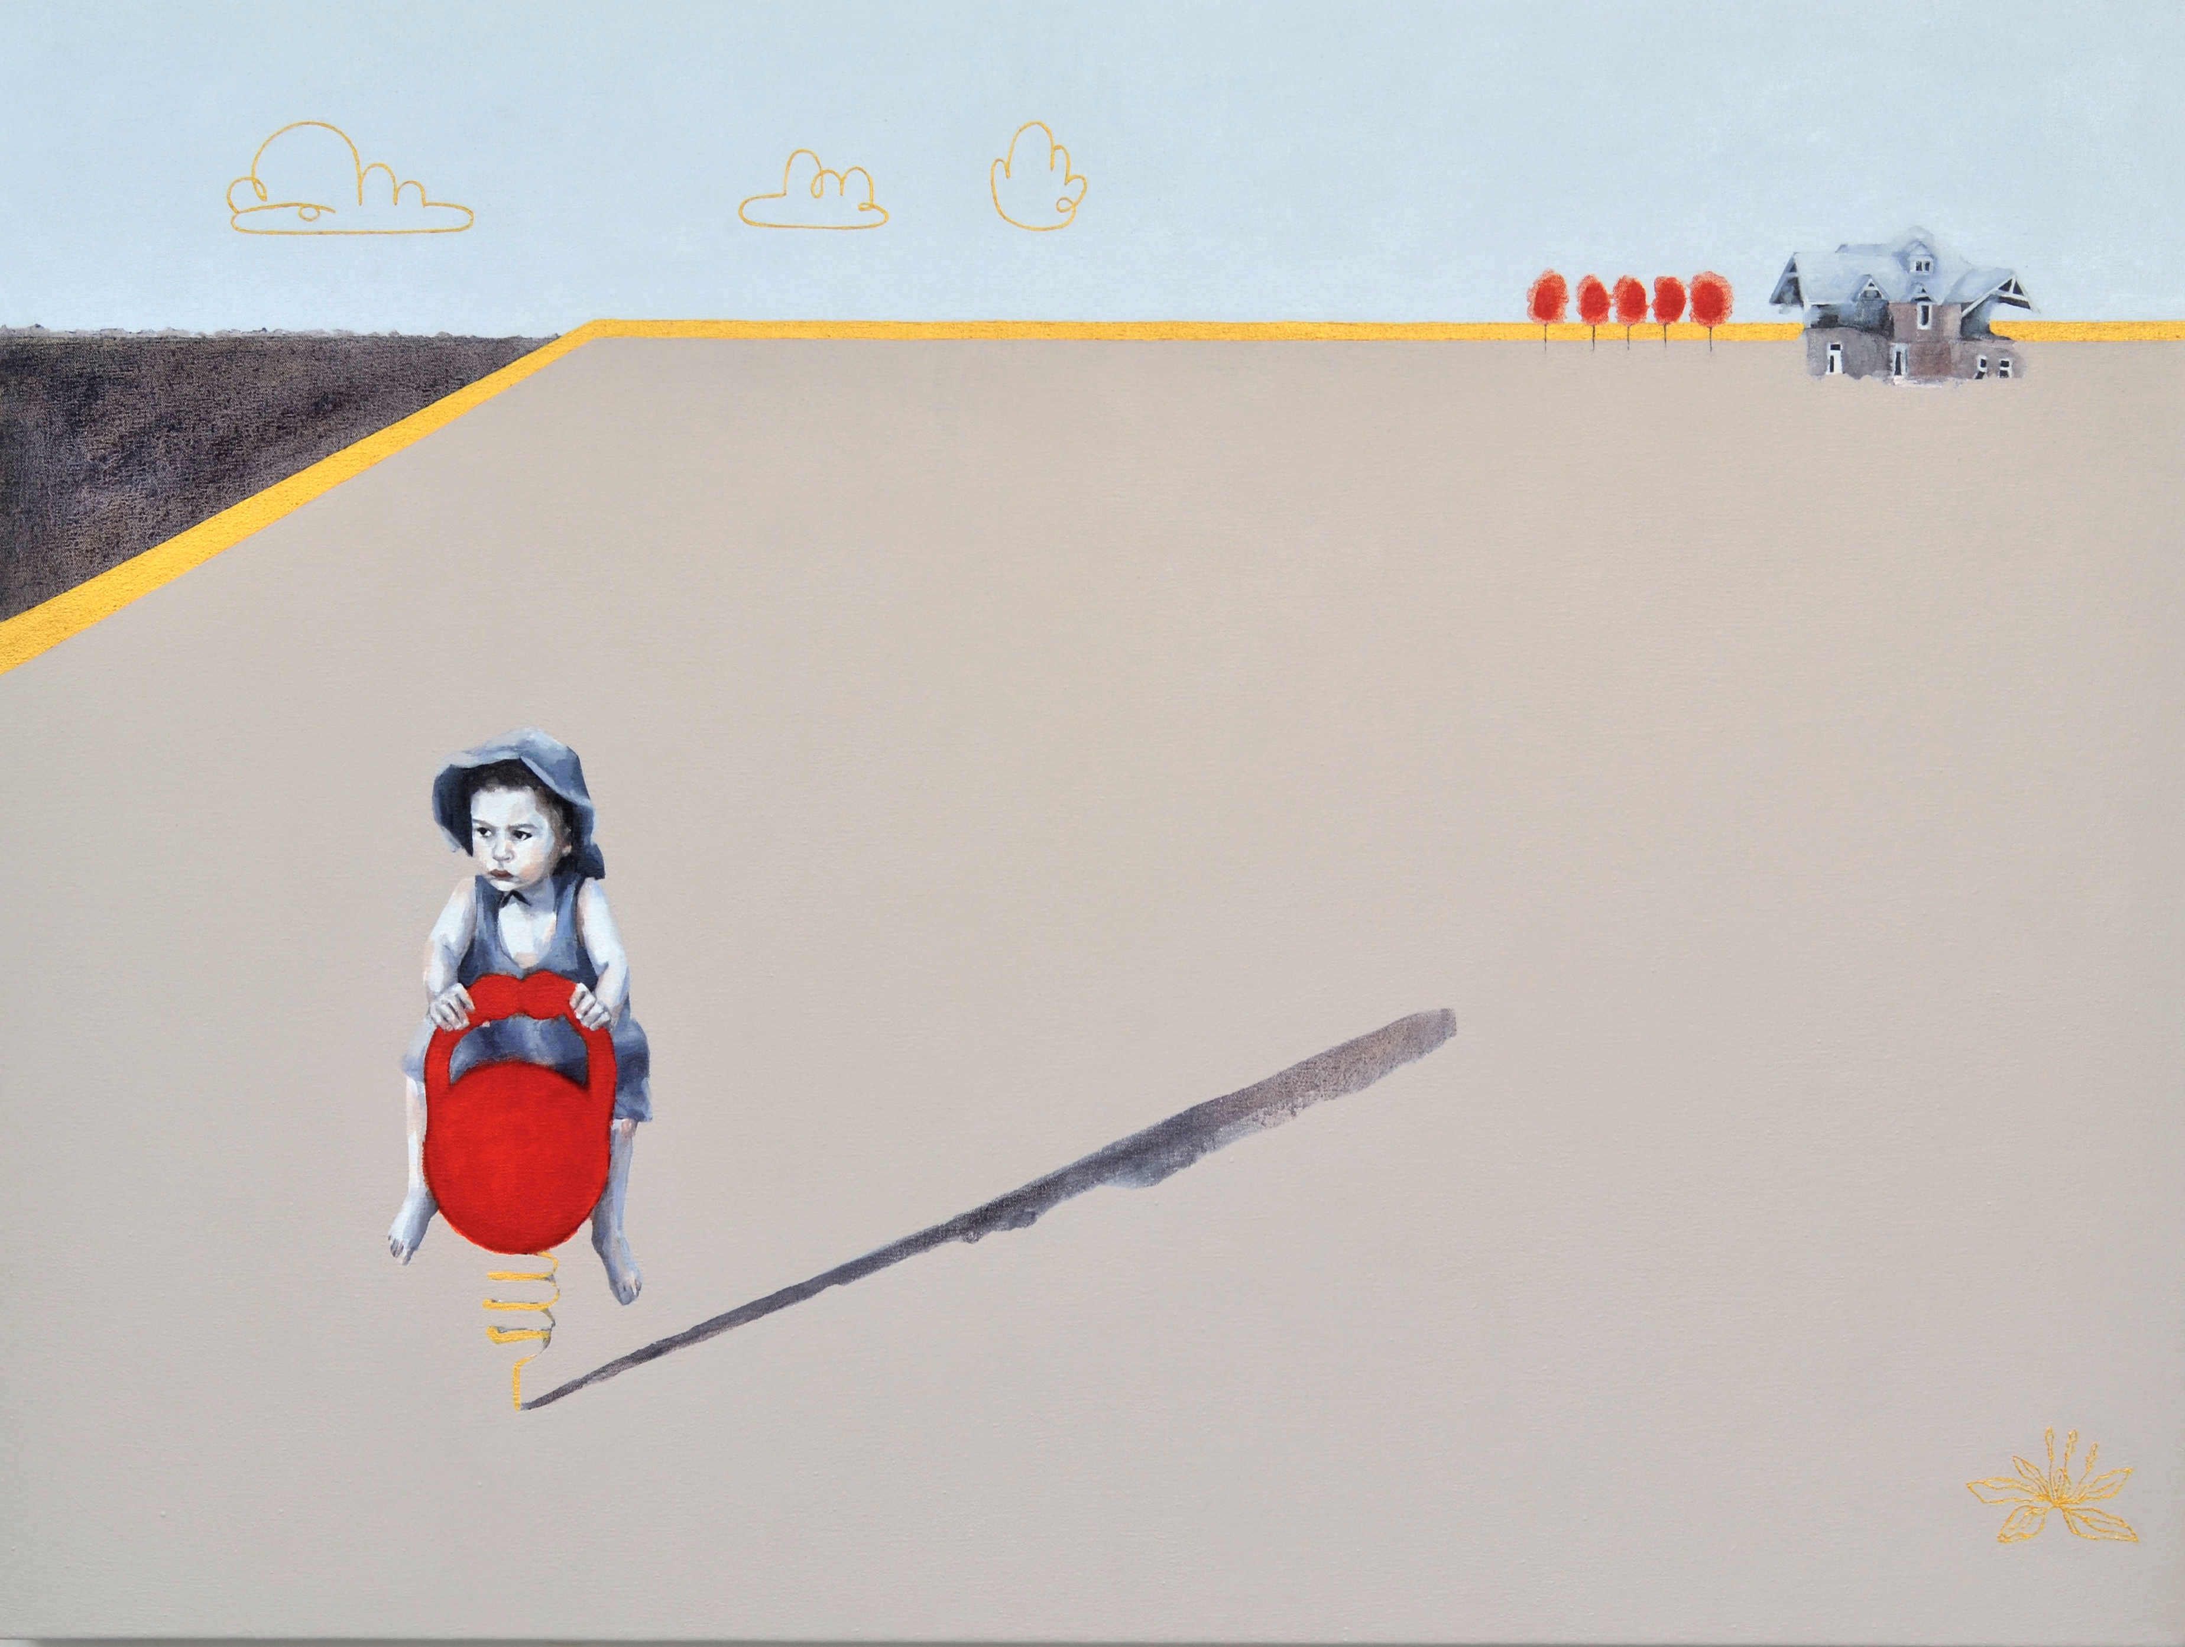
Climate change, sprawl, and the exploitation of natural resources are modern plagues that define our environment. Marks made by adults affect the places where children play, learn, and develop into future architects of this environment.
The fragmentation of time and space due to technology structures our digital spaces and affects how we perceive our literal spaces. Young people navigate these inherited spaces with little guidance. In Plagues, this narrative is articulated through the use of modern iconography, flattened spaces, gold line work, and decorative motifs. These devices reference the art of the Byzantine, an era similar to our own in its struggle to define morality and its feud between iconoclasts and iconolaters.
Maggie Mills
2017

